Biography
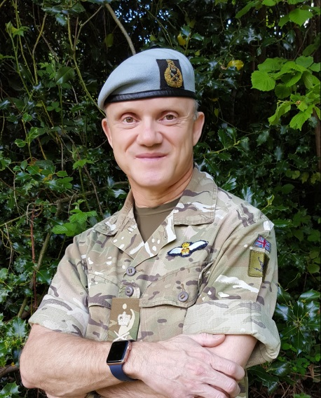

Director General Defence Safety Authority (DSA) Lieutenant General Richard Felton CBE

Richard Felton was commissioned as an Infantry officer into the Gloucestershire Regiment in 1985. He transferred to the Army Air Corps in 1998. He was awarded his Army Pilot’s Wings in 1990 and is qualified on the Gazelle (1990), Lynx (1999) and Apache AH-64D (2003).
He has commanded 669 Squadron Army Air Corps (1999 – 2001), 9 Regiment Army Air Corps (2004-06), 4th Mechanized Brigade (2009-11) and UK’s Joint Force Headquarters (2011-13), where as the Chief of Joint Force Operations he was UK Defence’s default 1* commander for contingent operations and in 2013 the Force Commander of the EU Battle Group. He took over command of the Joint Helicopter Command in March 2014.
On the staff, he was Chief of Staff of 7th Armoured Brigade (1996-99), SO1 LAND in the Directorate of Operational Capability (2001-03 – responsible for operational audits of UK Defence capabilities for Ministers and the Chiefs of Staff) and Chief of Staff of 1st (United Kingdom) Armoured Division (2007-09).
He has served on operations as an Infantry Platoon Commander in Northern Ireland (1987-89), as Chief of Operations of the UK led Multi-National Division in Banja Luka, Bosnia (1997), as Commander of the UK Joint Helicopter Force (Afghanistan) in 2006, as Chief of Staff of the UK led Multi-National Division in Basra, Iraq (2007-08) and as Commander of the UK led Multi-National Task Force Helmand in Afghanistan in 2010.
He is a graduate of the Army Staff College (1995-6) and the Higher Command and Staff Course (2007) and was a Member of the Royal College of Defence Studies (2013-14).
For operational service, he has been Mentioned in Dispatches (1991) for operations in Northern Ireland, appointed MBE (1998) for operations in Bosnia, OBE (2006) and CBE (2011) for operations in Afghanistan and awarded a Queen’s Commendation for Valuable Service for duties in Libya (2014).
Richard left the JHC in March 2017 to assume the appointment of Director General of the Defence Safety Authority in April 2017 on promotion to Lieutenant General.

