FROM CHURCHWARDEN GORDON WARWICK HAINES
Email: gwh.66@outlook.com

November 2018

Dear Fellow Carol Singers

GIFTS FOR CHILDREN - ST JAMES GARLICKHYTHE
DECEMBER 2018

Over the last decade many of the Livery Companies and other organisations which hold Carol Services in St James Garlickhythe have invited their members and guests to place gifts for disadvantaged children under the Christmas tree, which is kindly provided by the Vintners’ Company. The gifts are later collected by the Salvation Army and distributed to deserving children on or near Christmas Eve.

This year we would once again like to offer you the opportunity to donate gifts when you visit St James. If you and your guests would like to take part please bring a new gift with a purchase value of around £5, suitably wrapped and labelled with an indication of the nature of the present, what age child might appreciate it and whether it is intended for a boy or a girl or either.

As the gifts accumulate they are carefully stored and later collected by the Salvation Army for distribution which, as in previous years, I will oversee.

With best wishes for a peaceful festive season

Yours sincerely

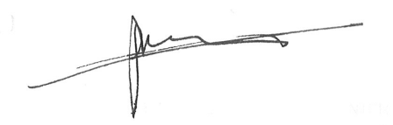

Gordon Warwick Haines MBE JP
Churchwarden, St James Garlickhythe & Master Horner

