Commissioner Ian Dyson

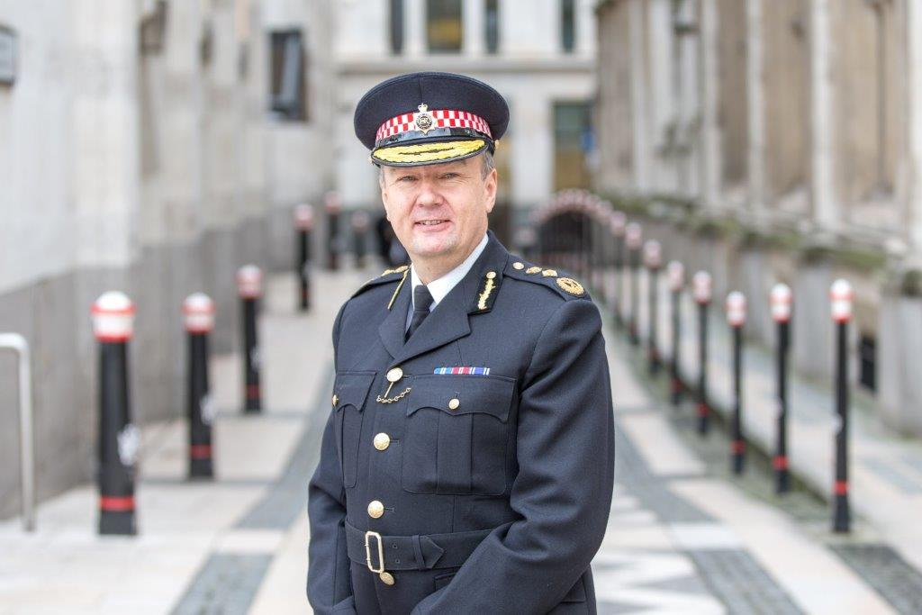

Ian has spent most of his life in London. He joined the Metropolitan Police in 1983, working within many different areas including crime and drug squads, vice and strategic planning. For eleven years, Ian was a public order cadre trained senior officer and has extensive experience of commanding the policing of large public events. Ian then joined Surrey Police as Assistant Chief Constable in June 2008 overseeing some of the highest confidence levels in the country and improving Neighbourhood Policing.

Ian Dyson joined the City of London Police as Commander in September 2010 leading initially on organisational change, and later as the chief officer lead on Economic Crime, expanding the Force’s national fraud responsibilities. He was also the National Police lead for Contact Management and led the national roll out for the 101 non-emergency number. Two years later he was promoted to Assistant Commissioner leading cultural change, leadership and performance within the Force, embedding staff empowerment and innovation.

From June 2016 Ian stepped up further from his Information Assurance portfolio and took National Policing Lead for the Information Management & Operational Requirements Coordination Committee. The City of London Police is also National lead force for Fraud and prominent in the areas of Protective Security and Cyber Crime.

He was promoted to Commissioner on the 3rd of January 2016 and was awarded the Queen’s Police Medal in the New Year Honours 2016.

